SPENDWISE
Project Documentation
Project Title: Spendwise

TEAM ID: SWTID-2026-3467

Team Leader: PRIYADHARSHINI K & priyadharshinikumar2007@gmail.com
Team Members: PAVITHRA N.R & pavithranr676@gmail.com
Team Members: KEERTHIKA M & keerthiharini2006@gmail.com
Team Members: SHINDIYA J & Shindiyadiya@gmail.com

Project Title:
SpendWise is a simple backend learning project built usingNode.js, Express.js, MongoDB, and JSON Web Token (JWT). The goal of this project is to help developers understand how to build a secure RESTful API for managing personal expenses. It includes core backend features such as user registration, login authentication, and protected routes using JWT. By implementing these features, learners can understand how authentication works and how to structure a backend application effectively.
In SpendWise, users can securely create an account, log in, and manage their expenses by adding, viewing, updating, or deleting records. All expense data is stored in MongoDB, while Express and Node.js handle server logic and API endpoints. JWT is used to protect user data and ensure that only authenticated users can access their expense information. This project serves as a beginner-friendly introduction to backend development and demonstrates how modern technologies work together to build a secure and scalable

Project Overview:
SpendWise is a backend learning project designed to help beginner developers understand how to build secure RESTful APIs using Node.js, Express.js, MongoDB, and JSON Web Token (JWT) authentication. The project demonstrates how to implement user registration and login, protect routes using JWT, and perform basic CRUD operations for managing expense data. By organizing the application with routes, controllers, and database models, SpendWise helps beginners learn how backend systems handle requests, store data securely, and manage authenticated user access in real-world applications.

Key Objectives:
- Provide secure user authentication using JSON Web Token (JWT) .
- Enable basic CRUD operations on user data such as transactions or records.
- Demonstrate database integration with MongoDB using Mongoose.
- Show how protected API routes work using middleware in Express.js.
- Maintain a simple and beginner-friendly backend architecture built with Node js.
Target Users:
- Beginner backend developers who want to learn how to build APIs .
- Students studying Node.js and Express.js for backend development.
- Freshers preparing for technical interviews and practical coding tests.
- Individuals interested in understanding authentication using JSON Web Token (JWT) and database usage with MongoDB.
- Learners looking for hands-on experience in creating and testing RESTful APIs.
Project Instruction:
spendwise is a backend-only project developed using Node.js and Express.js. The application focuses on building RESTful APIs for user authentication and expense management. It integrates MongoDB for database storage and uses JSON Web Token (JWT) to secure protected routes. The project is designed to help beginners understand backend architecture, API development, and secure data handling in a simple and practical way.

Quick Start:
npm init
npm install
npm run dev

Steps to Create the Project:
- Choose or create a directory for the backend project.
- Open the terminal and navigate to that directory.
- Initialize the project using Node.js with the npm init command.
- Install the required packages such as Express.js, Mongoose, jsonwebtoken, bcrypt, cors, and dotenv.
- Create project folders like models, routes, controllers, middleware, and config to organize the backend structure.
- Start the server using the npm run dev command.
- Test the API endpoints using Postman or Thunder Client at http://localhost:5000.
Pre-requisites:
Software Requirements
Software | Purpose
Node.js | JavaScript runtime for backend
MongoDB | NoSQL database for data storage
Npm | Package manager
Git | Version control system
Code Editor | VS Code or similar

Knowledge Requirements:
- Proficiency in JavaScript ES6+.
- Understanding of Node.js and Express.js for backend development.
- Familiarity with MongoDB and Mongoose for database operations.
- Knowledge of JSON Web Token (JWT) for authentication and route protection.
- Basic concepts of RESTful APIs and CRUD operations.
- Understanding of Git for version control and code management.

Thumbnail for Project:
- A simple, clean backend project thumbnail illustrating the tech stack: Node.js, Express.js, MongoDB, JWT, and CRUD APIs.
- Visual elements can include: server/server icon for Node.js, flow arrows for API requests, database icon for MongoDB, lock icon for JWT, and simple “CRUD” labels to show functionality.
- Keep it minimalist and clear to reflect a beginner-friendly backend learning project’
- Use a cohesive color scheme (like green for Node.js, yellow for MongoDB) to visually represent the technologies.
- Include simple icons or symbols to indicate secure authentication and data management, making the purpose of the project instantly clear.
- Use icons for Node.js, MongoDB, and JWT.
- Show arrows or symbols representing CRUD operations.

Project Architecture Image:
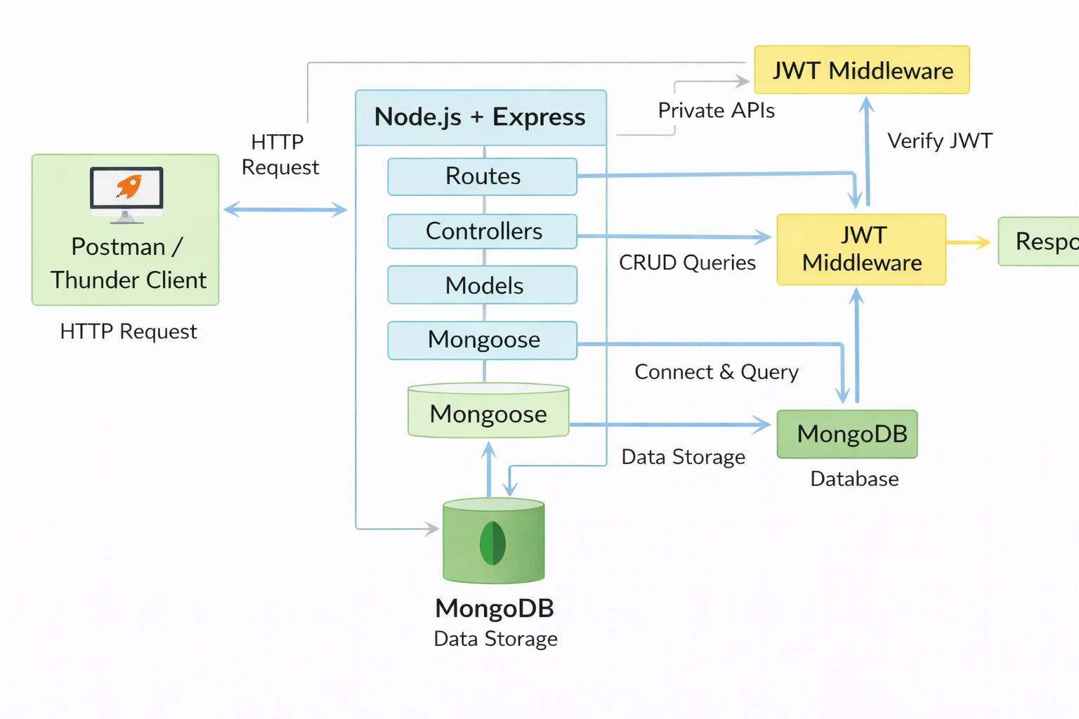

Legend:
- JWT Middleware: Verifies user tokens for secure access.
- Mongoose: ODM for MongoDB, manages schemas & queries.
- Postman / Thunder Client: Tools for sending API requests.
- Routes: Define API endpoints to handle client requests.
- Controllers: Contain business logic, process requests, and send responses.
- Models: Define data schemas and interact with the database through Mongoose.
Technical Architecture:
Backend Architecture (Node.js + Express)
- Controllers: Handle business logic for authentication and CRUD operations.
- Models: Mongoose schemas for User and Transaction entities.
- Routes: API endpoints for authentication and CRUD actions.
- Middleware: JWT verification to secure routes and protect requests.
- Configuration: Database connection setup and environment variable management.
Database Architecture (MongoDB)
- Users Collection:
  - _id, name, email, password (hashed), createdAt.
- Transactions Collection:
  - _id, userId (foreign key referencing Users), title/description, amount/value, createdAt.
- Relationship:
  - One User → Many Transactions (one-to-many relationship).
- Controllers & Routes: Handle business logic and define API endpoints for authentication and CRUD operations.
- Models & Middleware: Mongoose schemas manage data structure, while JWT middleware secures routes.
- Database Structure: MongoDB with Users and Transactions collections; one-to-many relationship between Users and Transactions.

ER Diagram:
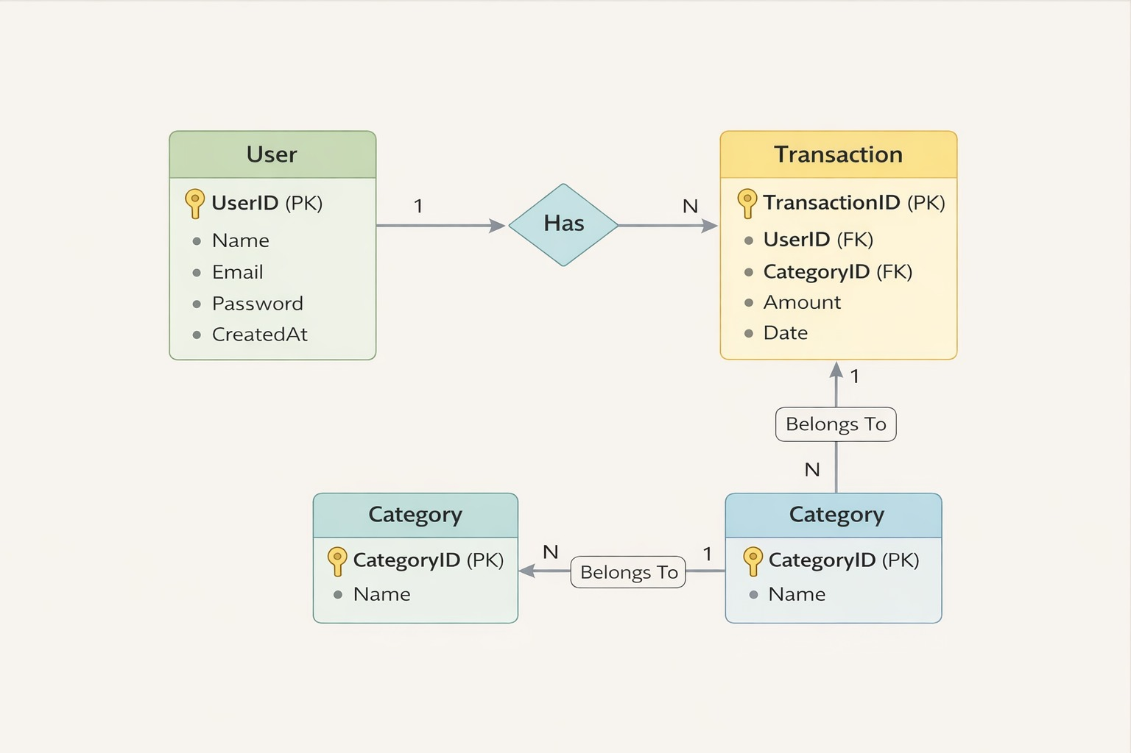

Features:
Factures Description
- User Registration & Log JWT-based authentication.
- CRUD Transactions Create, Read, Update, Delete operations.
- Protected Routes Secured with JWT middleware.
- Database Integration MongoDB with Mongoose.
- Data Validation Ensures correct and secure input.
- Error Handling Graceful error responses.
- Security & Reliability Overall best practices for backend.

Roles and Responsibilities:
Student / Developer
- Develop backend functionality.

- Build API endpoints.

- Test APIs using Postman or Thunder Client.

- Commit and push code to GitHub.

System (Backend)
- Verify users via JWT authentication.
- Perform CRUD operations on data.
- Manage data storage and retrieval in MongoDB.
- Secure private routes using middleware.
EXPLANATION:
- Development & API Management: Write backend code, create APIs, and test them using Postman/Thunder Client.

- Version Control: Push and manage code on GitHub.

- Backend System Functions: Authenticate users with JWT, handle CRUD operations, and secure private routes while managing MongoDB data.
Users Flow:

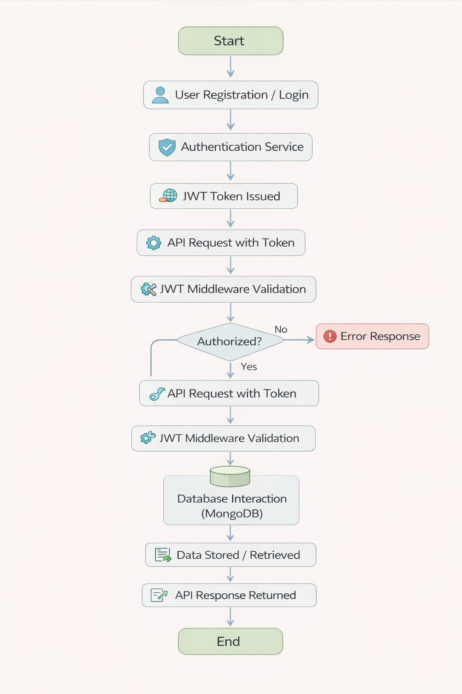

PROJECT SETUP AND CONFIGURATION
Folder Structure
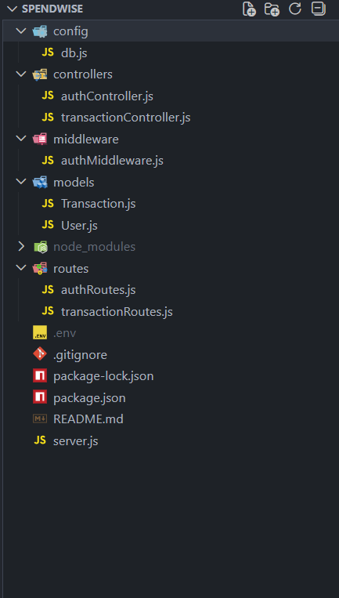

Project Setup
1. Install required tools:
- Node.js
- MongoDB
2. Create project folders:
- server folders (models, routes, controllers, middleware, config)

3. Install Backend Packages:
- Express
- Mongoose
- Cors
- Jsonwebtoken
- Bcrypt
- Dotenv
BACKEND DEVELOPMENT
- Setup Express server
- Create server.js file
- Create .env file and define PORT and DB URL
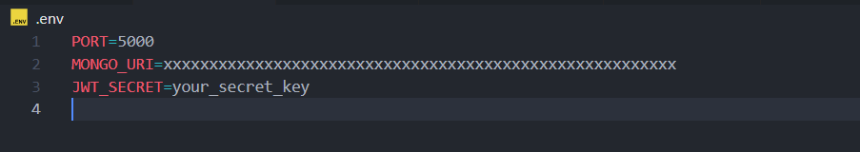
- Configure middleware (cors, express.json)
- User Authentication:
  - Create Register and Login routes
  - Generate JWT token
  - Protect routes using middleware

- Define API Routes:
  - Auth routes
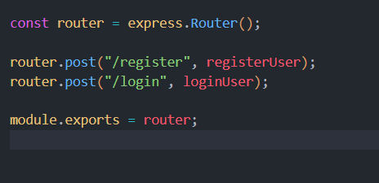

  - Transaction CRUD routes

- Implement Data Models:
- User schema
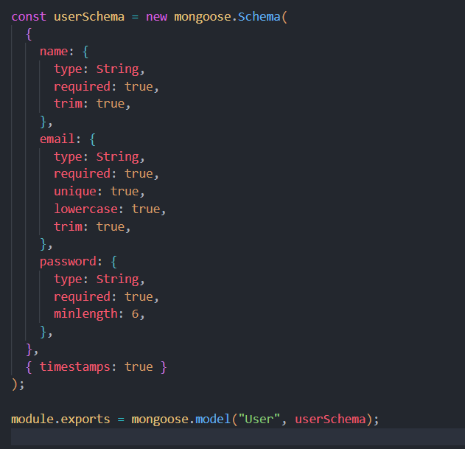

  - Transaction schema
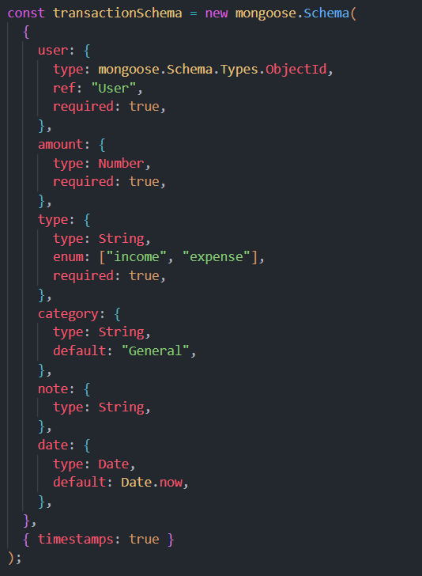
- Implement CRUD operations
- Add basic error handling

DATABASE DEVELOPMENT
Configure MongoDB
- Use MongoDB Atlas or local MongoDB
- Store connection URL in .env file
- Connect using Mongoose

Create Database Connection
- Create a config file for DB connection

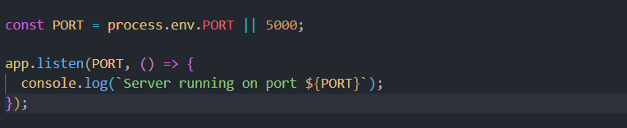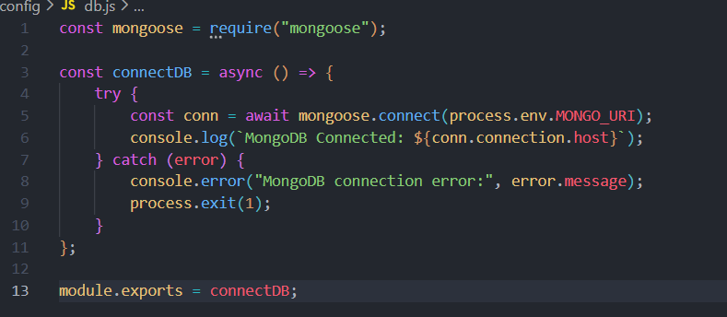


- Use mongoose.connect()
- Handle success and error cases

Create Schema and Models
User Model:
- Name
- email
- password

Data / Transaction Model:
- userId
- title / description
- amount / value
- timestamps PROJECT EXECUTION
Project Execution Steps:
- Start MongoDB
- Run backend server
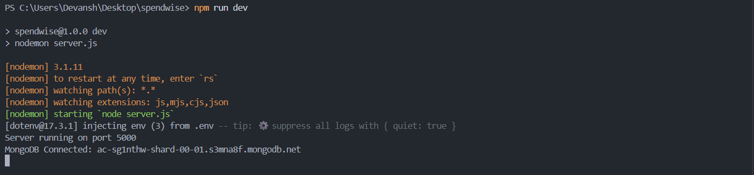

- Test Register API
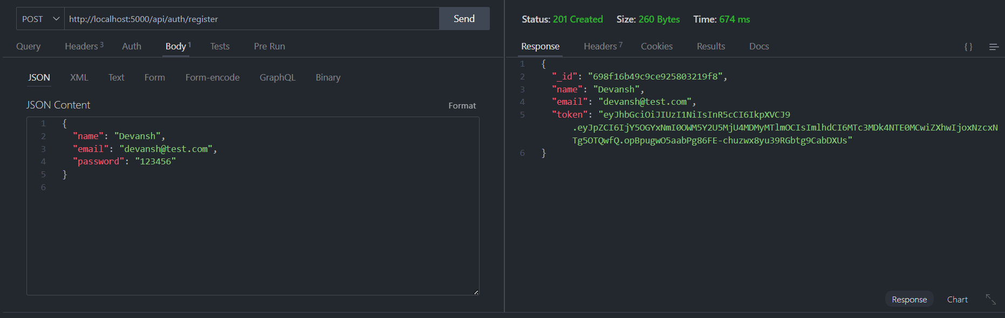

- Test Login API
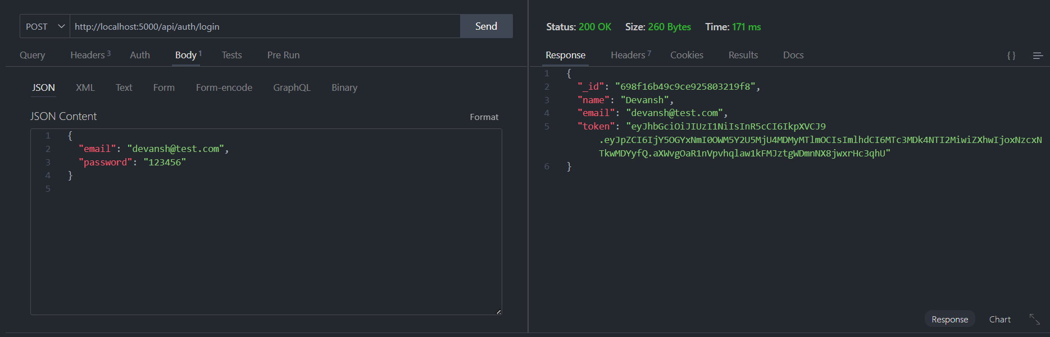

- Copy JWT token
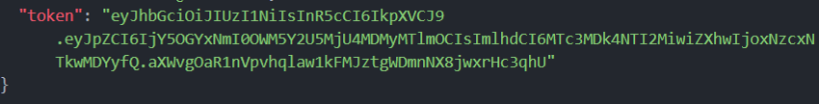
- Use token to access protected CRUD APIs
- Perform Create, Read, Update, Delete operations

OUTPUT SCREENSHOT

- Register API
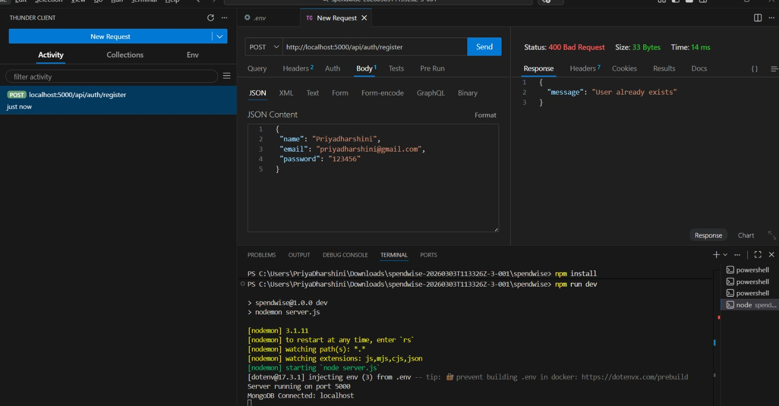

2. Login API
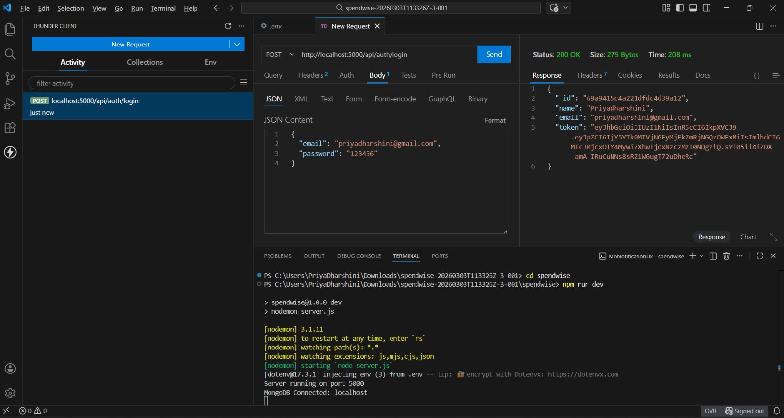

3.Create Transaction
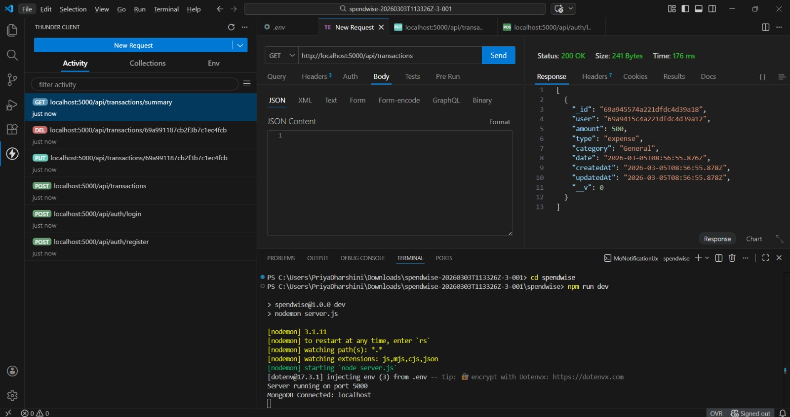

4.Get information
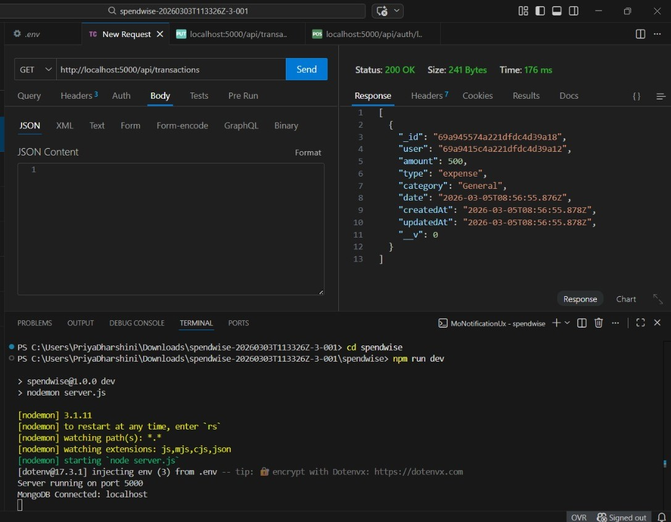
5.Update API
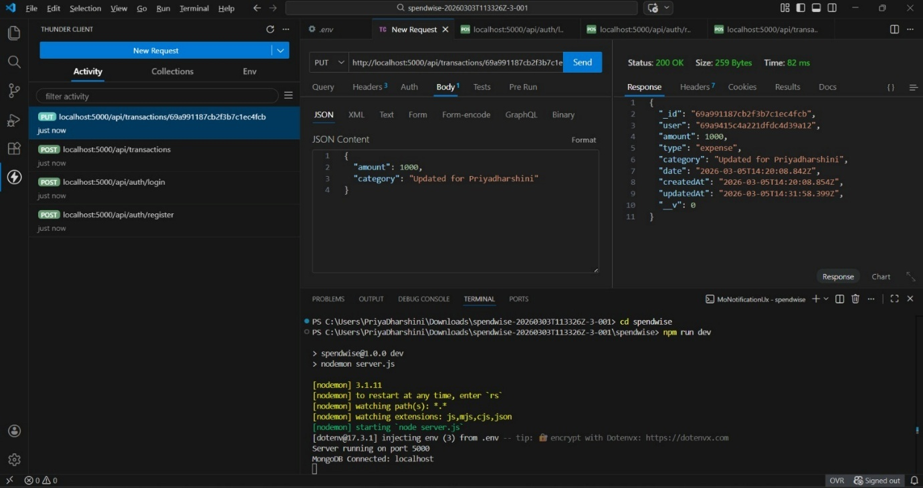

6.Delete API
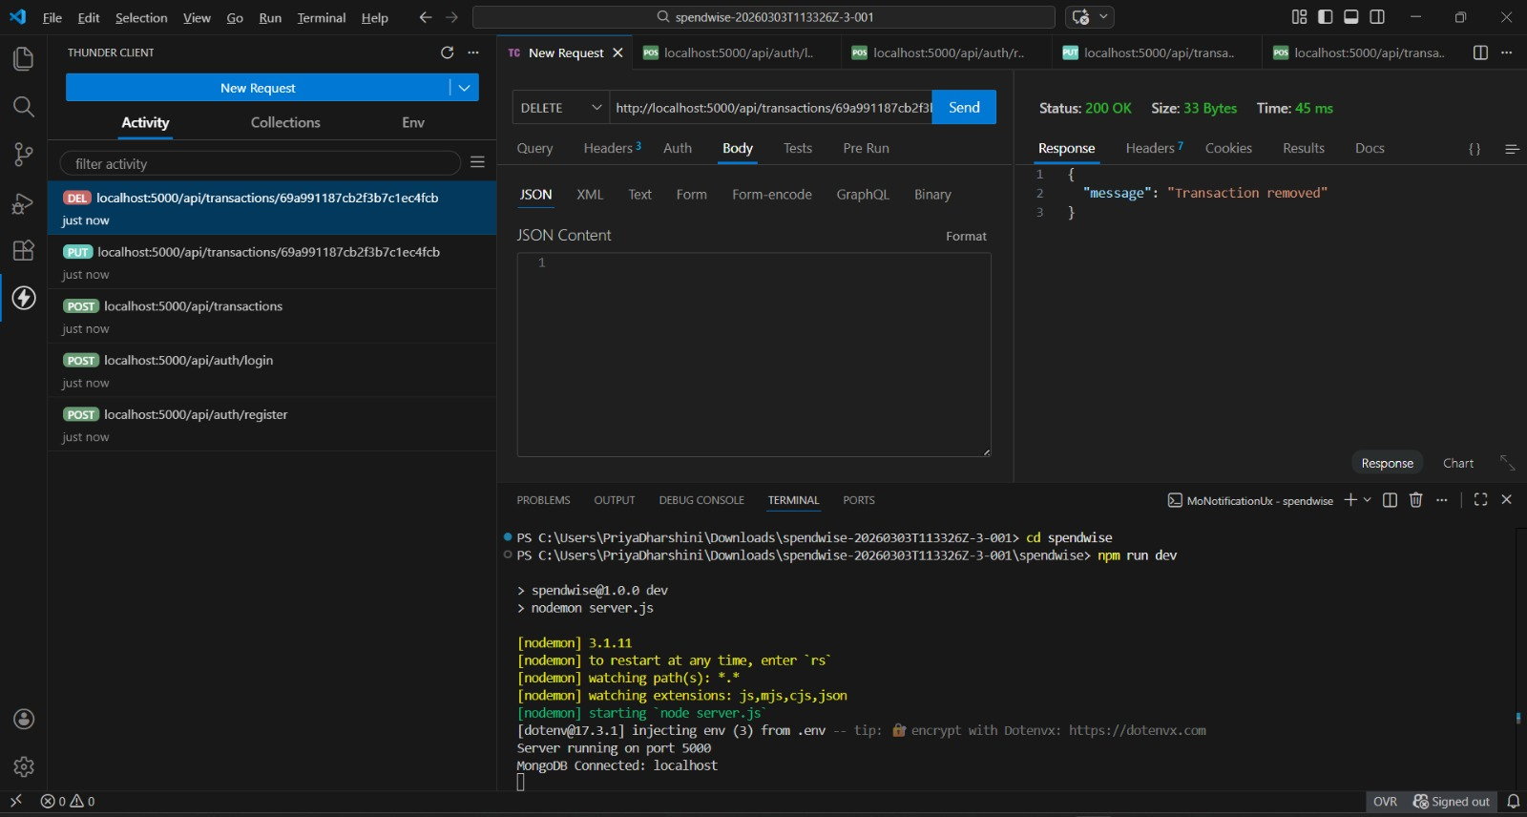

DEMO VIDEO LINK:

https://drive.google.com/file/d/1AEDxXEgEcWQMrVCLPbeLRZmebwh13-RZ/view?usp=sharing

